**Questioning and Feedback Notetaking Guide**

<https://dcsd.sharepoint.com/sites/DCSDGifted> **or** [**worksheetless.com**](http://worksheetless.com/)

**Which One Doesn't Belong**

<http://wodb.ca/>

**Independent Reading of Assigned Article**

**Block Party**

Protocol from <https://www.schoolreforminitiative.org/download/block-party/> with someone who read a different article.

* 5 Strategies for Questioning with Intention
* A New Rhythm for Responding
* Can We Talk
* Designing Great Hinge Questions
* How to Make Your Questions Essential
* Let’s Switch Questions Around
* Making Questions Flow
* Making the Most of Multiple Choice
* Predicting Student Misconceptions in Science
* Start with Higher Order Questions
* What Children Learn from Questioning
* Who is Asking?

**Sort/Categorization**

**Perspective Walk**

**Resource Exploration**

**Four Corners Activity/People Graph**

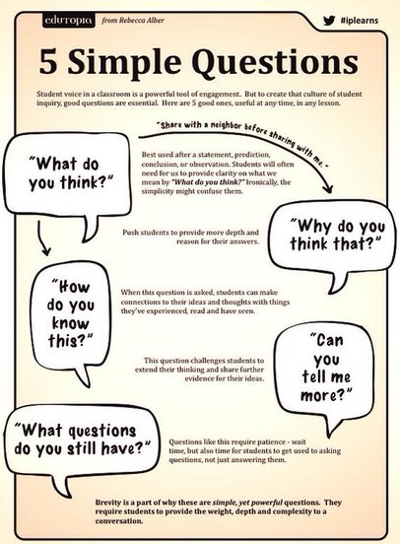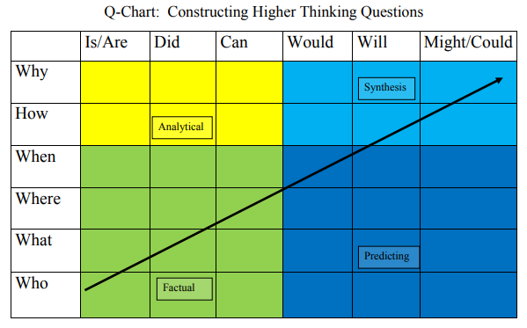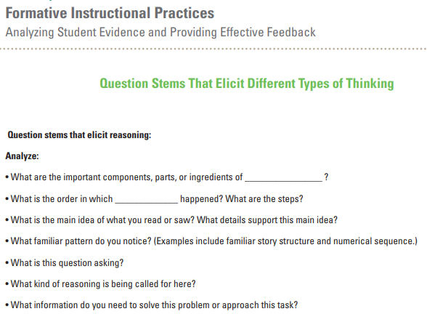

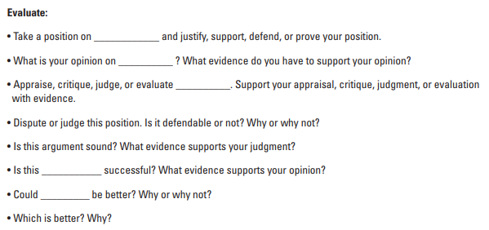

**Thoughtful Learning Line**

**Listen to *Thanks for the Feedback... I Think***

**Community Circle (Response to Literature)**

**Independent Reading of Self-Selected Article**

**Save the Last Word for Me**

Protocol from <https://schoolreforminitiative.org/doc/save_last_word.pdf> with those reading same article.

* 7 Keys to Effective Feedback
* Do They Hear You?
* How I Learned to be Strategic about Writing Comments
* Feedback Is a Two-Way Street
* How Am I Doing?
* Know Thy IMPACT
* Making TIME for Feedback
* More Than a Checklist
* The Power of Peers
* The Secret of Effective Feedback

**Writing Activity –** Summarize the article you chose and its implications for your classroom.

**TAG Feedback Protocol**